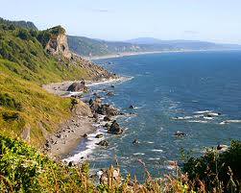

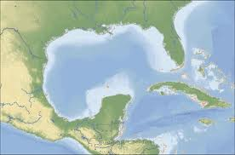

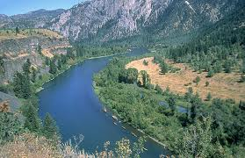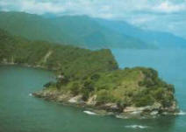

[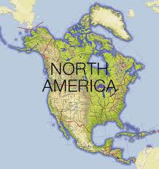](http://www.google.com/imgres?biw=1680&bih=841&tbm=isch&tbnid=wEgo4TEqfoOmAM:&imgrefurl=http://www.dk.co.uk/static/cs/uk/11/worldfactfile/northamerica.html&docid=avboqw5eZ9Lq0M&imgurl=http://www.dk.co.uk/static/cs/uk/11/worldfactfile/images/contin_n_america.gif&w=377&h=398&ei=rGA8UrWTPO_lygGtq4D4Dg&zoom=1&ved=1t:3588,r:82,s:0,i:343&iact=rc&page=3&tbnh=179&tbnw=160&start=63&ndsp=40&tx=92&ty=89)

