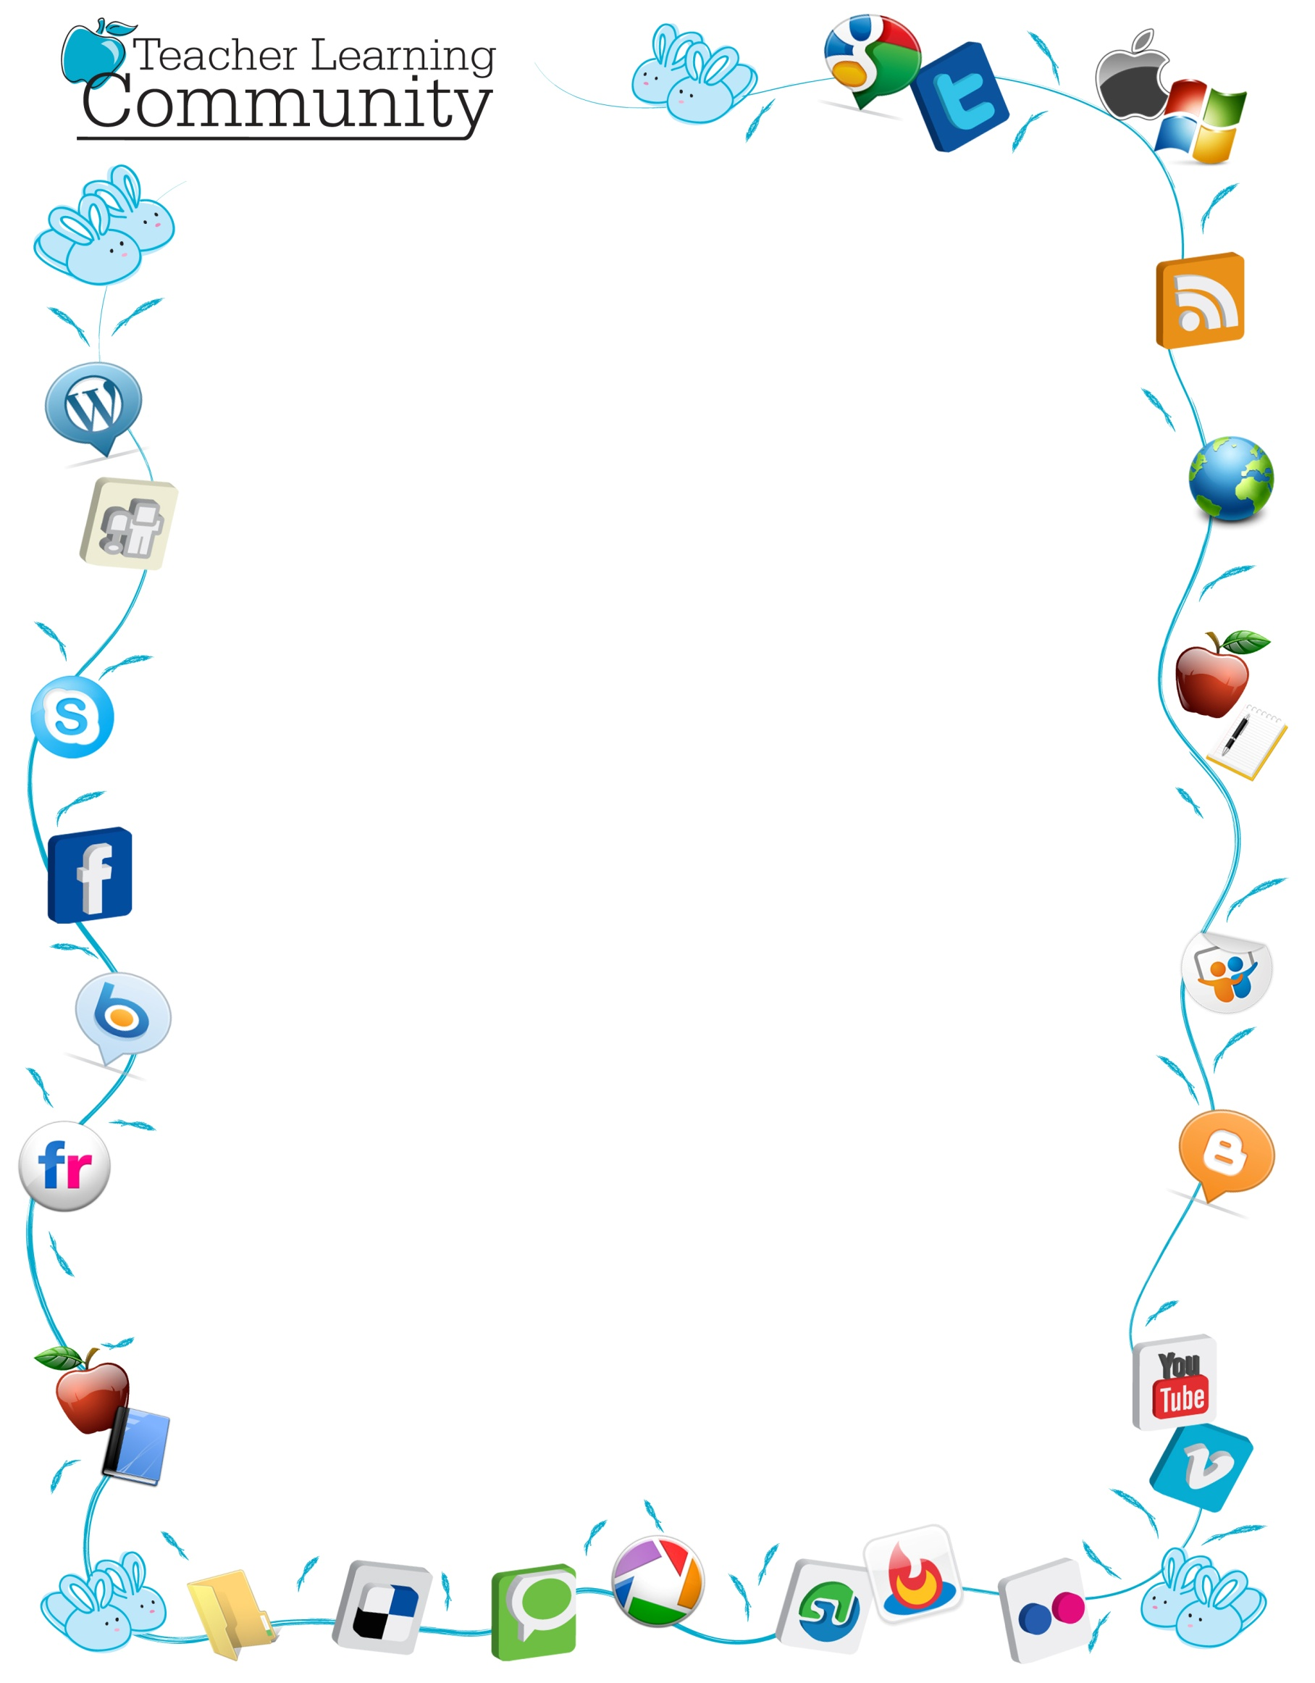

Dear USF Community:

The Frederickson School of Education has received a grant from SimpleK-12, an Orlando-based, online teacher professional development company that is providing ALL USF students and faculty a free one-year membership to their premier-learning portal, *The Teacher Learning Community* has over 100,000 teacher members from around the world. USF's free membership is valid September 1, 2012 – August 31, 2013.

**WHAT IS SIMPLEK-12?**

SimpleK-12 is an online learning portal available 24/7 and can be accessed from your office, home, dorm room, or school. Many resources are applicable for USF students and faculty regardless of their college affiliation, area of expertise, or major. The site has:

* Over 1,000 hours of self-paced technology related online courses,
* Hundreds of live and recorded webinars, and
* The opportunity to share resources and collaborate with thousands of educators around the world.

If you would like additional information on some of the content in the Teacher Learning Community, click here: <http://community.simplek12.com/scripts/student/webinars/Default.asp>

**HOW TO ENROLL:**

**To enroll free to the premier site, go to USF's enrollment page at**

[http://community.simplek12.com/scripts/student/register.asp?p=9b2acd60-4fdc-4864-bace-e89e1207fcd6](https://mail24.usiouxfalls.edu/owa/redir.aspx?C=SuGBmhYvGEixsP2f7okoXMd1HS6cSs8ISEIYIPk-lEDhXI-7ZMNzlIYfJDZPW-xSZrvNtH1H1fU.&URL=http%3a%2f%2fcommunity.simplek12.com%2fscripts%2fstudent%2fregister.asp%3fp%3d9b2acd60-4fdc-4864-bace-e89e1207fcd6)