Tweet | Response
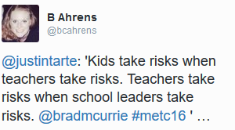 | This was a very interesting tweet! I really believe this to be true though, and live it in my school. If the school leaders are not willing to take risks or stand behind the teachers as they take risks, then the whole systems falls apart. What is the point of trying if you don’t have the back up for it, or school leaders don’t even let you try.
#edtech – week 1

# – week 1

#edtech – week 2

# - week 2 | .
#edtech – week 3

# - week 3

#edtech – week 4

# _ week 4

#edtech – week 5

# - week 5

#edtech – week 6

# - week 6

