TECHNOLOGY IN EDUCATION
EDU 240
FALL, 2017
Instructor: Dr. Arlys E. Peterson
1:00 - 2:15 - Tuesdays and Thursdays
Glidden RM 115
Office: Education Department
Office Hours: 11:00 a.m. – 12:30 p.m.
e-mail: arlys.peterson@usiouxfalls.edu
Class Web Page: http://faculty.usiouxfalls.edu/arpeterson/TECHINEDspring2017.htm
======================================================================
Vision Statement-University of Sioux Falls
The University of Sioux Falls, a Christian University in the liberal arts tradition, educates students in the humanities, sciences, and professions. The traditional motto of the University if Culture for Service; that is, we seek to foster academic excellence and the development of mature Christian persons for service to God and humankind in the world.

Course Description:
Designed as an introductory computer applications course for teachers, this class provides experience in technology programs for K-12 classrooms. The course includes hands-on experience with telecommunications, multimedia, hypermedia, and K-12 software programs. Candidates also prepare a website for portfolio preparation. (3 s.h.)

Credit Hour Policy Statement:
The course is a face-to-face format course that meets one 50-minute session per week per credit hour with a minimum of two hours of out-of-class work per week per credit hour for an approximate 15-week semester, or its equivalent.

Textbook:
Online Resources

Course Requirements and Evaluation:
Attendance Policy: Attending class is very important! After three absences, you will be asked to drop the class. Being late more than five minutes to class will count as an absence.
Assignments: All assignments are due one week after they are assigned, unless otherwise told. If they are 1-5 days late, only half of the points will be given. After 5 days, no points will be given. All assignments and due dates are listed on the LMS.
Evaluation: All evaluation methods and Rubrics/Checklists for the projects, journal critiques, and presentation are on the class web page.
Class Web Page: http://faculty.usiouxfalls.edu/arpeterson/TECHINEDspring2017.htm
Wiki: http://techinedusf2016.wikispaces.com/
Drop Class: September 8 – last day to Add/Drop a Course without record
October 27 – Last day to withdraw from a Fall class

Course Requirements:

1. Completion of assignments as assigned in class
2. Completion of SD Standards technology/ISTE projects
3. Completion of educational technology research reports
4. Completion of a technology presentation
5. Completion of a Wiki page with all assignments posted on it
6. Posting assignments on the LMS
7. Attendance and participation in class discussions

Grading Scale:
96-99 = A
93-95 = A-
90-92 =B+
87-89 = B
83-86 = B-
80-82 = C+
78-79 = C
75-77 = C-

Instructional Methods:
Lecture, Discussions, Hands-on Projects

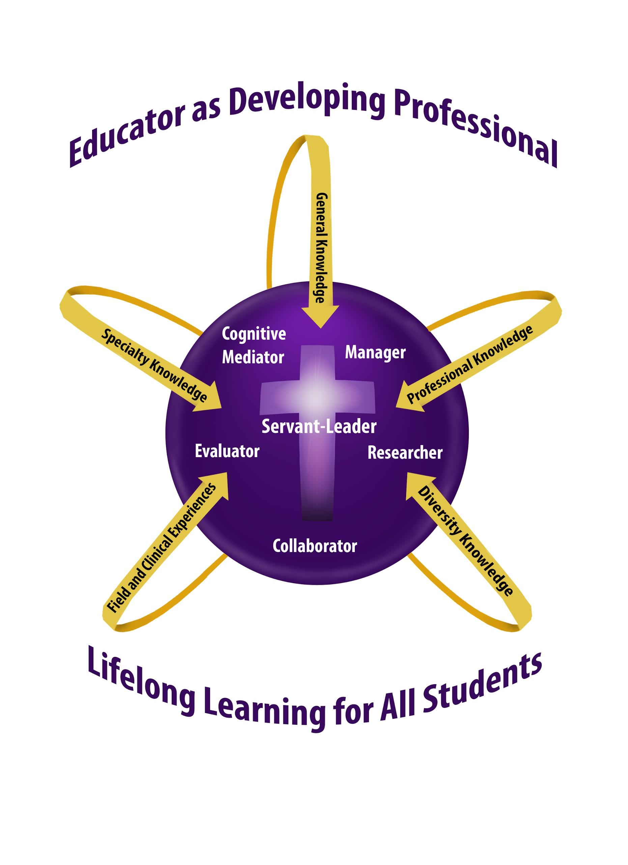
Knowledge Base
The knowledge base for candidates in all teacher education programs at University of Sioux Falls is based on the conceptual framework, “Teacher as Developing Professional.” Coursework may emphasize some or all of the components of the framework: cognitive mediator, manager, researcher, communicator, evaluator, and servant-leader.

As cognitive mediator, the teacher helps students to become independent learners who construct meaning by combining new information with their own background knowledge.

As researcher, the teacher seeks to improve educational practices within the school setting, using an inquiry approach to serve students more effectively.
As servant leader, the teacher is able to integrate research on the development of moral reasoning, values, and ethical sensitivity into the classroom while following the model of empathetic personal interaction provided by Jesus Christ.
As evaluator, the teacher maximizes students’ learning by using a full range of formal and informal information-gathering processes in order to respond appropriately to student individual differences.
As collaborator, the teacher is skill in modes of communication that will enable effective communication and collaboration with other educators, parents, and families.
As manager, the teacher plans and organizes the learning environment, established and maintains a positive learning climate, and implements effective intervention strategies.

Professional Education Requirements
This class was designed to show alignment with the USF School of Education’s “Teacher as Developing Professional” Curriculum Model, the South Dakota Professional Education Requirements -SDPER24:16:08:36 - and ISTE Standards.

2017 ISTE Teacher Standards:
- LEARNER: Educators continually improve their practice by learning from and with others and exploring proven and promising practices that leverage technology to improve student learning.
- LEADER: Educators seek out opportunities for leadership to support student empowerment and success and to improve teaching and learning.
- CITIZEN: Educators inspire students to positively contribute to and responsibly participate in the digital world.
- COLLABORATOR: Educators dedicate time to collaborate with both colleagues and students to improve practice, discover and share resources and ideas, and solve problems.
- DESIGNER: Educators design authentic, learner-driven activities and environments that recognize and accommodate learner variability.
- FACILITATOR: Educators facilitate learning with technology to support student achievement of the ISTE Standards for Students.
- ANALYST: Educators understand and use data to drive their instruction and support students in achieving their learning goals.

InTASC TEACHING STANDARDS
The InTASC Model Core Teaching Standards
Standard #1: Learner Development.
Standard #2: Learning Differences.
Standard #3: Learning Environments.
Standard #4: Content Knowledge
Standard #5: Application of Content.
Standard #6: Assessment.
Standard #7: Planning for Instruction.
Standard #8: Instructional Strategies.
Standard #9: Professional Learning and Ethical Practice.
Standard #10: Leadership and Collaboration.

CLASS OBJECTIVES

- Students will demonstrate competencies in using technology by creating technology projects that follow the South Dakota State Curriculum Standards and National ISTE Standards in their area of teaching. (Cognitive Mediator, Researcher, Evaluator, Collaborator; ISTE 1-7; InTASC 7 & 8)
- Students will demonstrate competencies in using technology hardware and software that are being used in educational environments. (iPads, Web 2.0 Tools, Chromebooks, VR, SmartBoards, Wikis, Twitter, and online multimedia programs). (Cognitive Mediator, Researcher, Evaluator, Collaborator; ISTE 1-2; InTASC 7 & 8)
- Students will gain information on setting up a Personal Learning Network through the use of online tools. (Twitter, Blogs, Chat Rooms, Facebook) (Cognitive Mediator, Researcher, Collaborator; ISTE 4; InTACS 9 & 10)
- Students will research and learn how technology is enhancing the 21st Century Skills of Students. (Researcher, Evaluator, Collaborator; ISTE 1-5; InTASC 9)
- Students will learn how to use online Webinars to gain professional development in their major area of study. (Researcher, Evaluator, Collaborator; ISTE 1-5; InTASC 9)
- Students will research how technology is being used in K-12 education environments and how technology used around the world is affecting K-12 education. (Cognitive Mediator, Researcher, Evaluator, Collaborator; ISTE 1-7; InTASC 9)
- Students will research Internet Safety and Bullying in K-12 School Environments. (Researcher, Evaluator, Collaborator; ISTE 3; InTASC 9)
- Students will demonstrate competencies in developing an online technology lesson plan in their area of study. (Cognitive Mediator, Researcher, Evaluator, Collaborator; ISTE 1-2; InTASC 7 & 8)

Accommodations:

COMPLIANCE WITH THE AMERICANS WITH DISABILITIES ACT: The Americans with Disabilities Act (ADA) is a federal anti-discrimination statute that provides comprehensive civil rights for persons with disabilities. Among other things, this legislation requires that all students with disabilities be guaranteed a learning environment that provides for reasonable accommodation of their disabilities. If you believe you have a disability requiring an accommodation, please contact Learning Accessibility Services at (605) 331-6740 or access@usiouxfalls.edu. Accommodations can only be arranged through this office, which is located in the Academic Success Center (McDonald Center).

Honesty Statement:
USF holds firmly to the conviction that personal and intellectual integrity should be fundamentals at a Christian university. For this reason, USF expects all students and employees of the university to act honestly, ethically, and fairly and to avoid activities that would compromise the academic mission of the university. Academic misconduct, including plagiarism, will result in written notification to the student, his/her academic advisor, the department head of the offered course, and the Vice-President of Academic Affairs. Plagiarizing occurs when one does not cite work taken from books, journals, works of others, or electronic sources. Full information can be found at: https://www.usiouxfalls.edu/academic/student_handbook
USF Academic Success Center
To assist students in enriching their intellectual lives and pursuing academic success, USF provides a variety of services through the Academic Success Center (ASC). The ASC coordinates with the USF Math Center, the USF Writing Center, and other campus programs to aid students seeking to master course content or to develop study skills (e.g., time management, note taking, test taking, reading strategies) necessary to become effective, life-long learners. The services of the USF Academic Success Center—located in the McDonald University Center—are free. For additional information, including the schedule of available services, please visit the ASC web page at http://www.usiouxfalls.edu/asc, or contact Dr. Greg Dyer (greg.dyer@usiouxfalls.edu), Director of the Academic Success Center.

USF Writing Center
An excellent avenue for receiving thoughtful feedback on your writing is the USF Writing Center, located in the lower level of Mears Library. The services of the USF Writing Center are free, and they are available to you either by appointment or on a drop-in basis. For additional information about the USF Writing Center, including the hours of operation and the services they offer, please check the website at www.usiouxfalls.edu/writing_center.

CLASS SCHEDULE ON THE INTERNET
CLASS ASSIGNMENTS LISTED ON THE LMS

Status of the Syllabus: This syllabus results from the instructor’s effort to represent fairly the plan for this course. Circumstances may cause the instructor to make changes in the plan, but such changes will not be capricious and will be made in a timely fashion. Please speak with your instructor if there is anything in the syllabus about which you are unclear.

