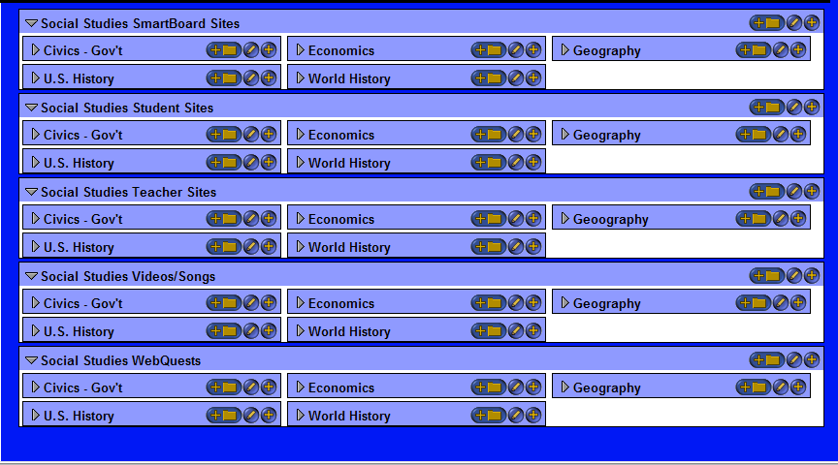
5 SmartBoard sites for each standard; 10 Student and 10 Teacher sites for each; 5 Video or song sites for each; 5 WebQuests for each

