How-To: Link Audio Recordings to QR Codes
Audio recordings can definitely support students who have trouble reading directions or need extra help with new vocabulary words. This is one way to make QR codes talk to students but if you’d like to add your own voice to a QR code, here’s how:
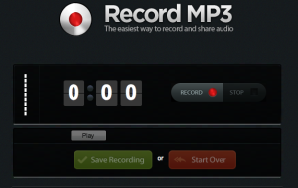
1. Open up RecordMP3.org and record your audio
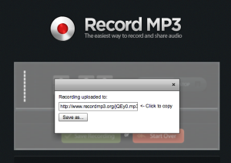
2. Click Save and copy the link that appears on the screen
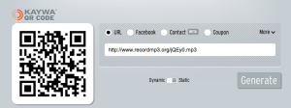
3. Paste the URL into a QR code generator
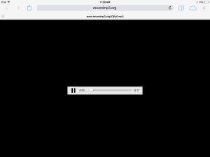
4. When students scan the QR code they’ll be taken straight to the audio file and can press play to hear your voice

