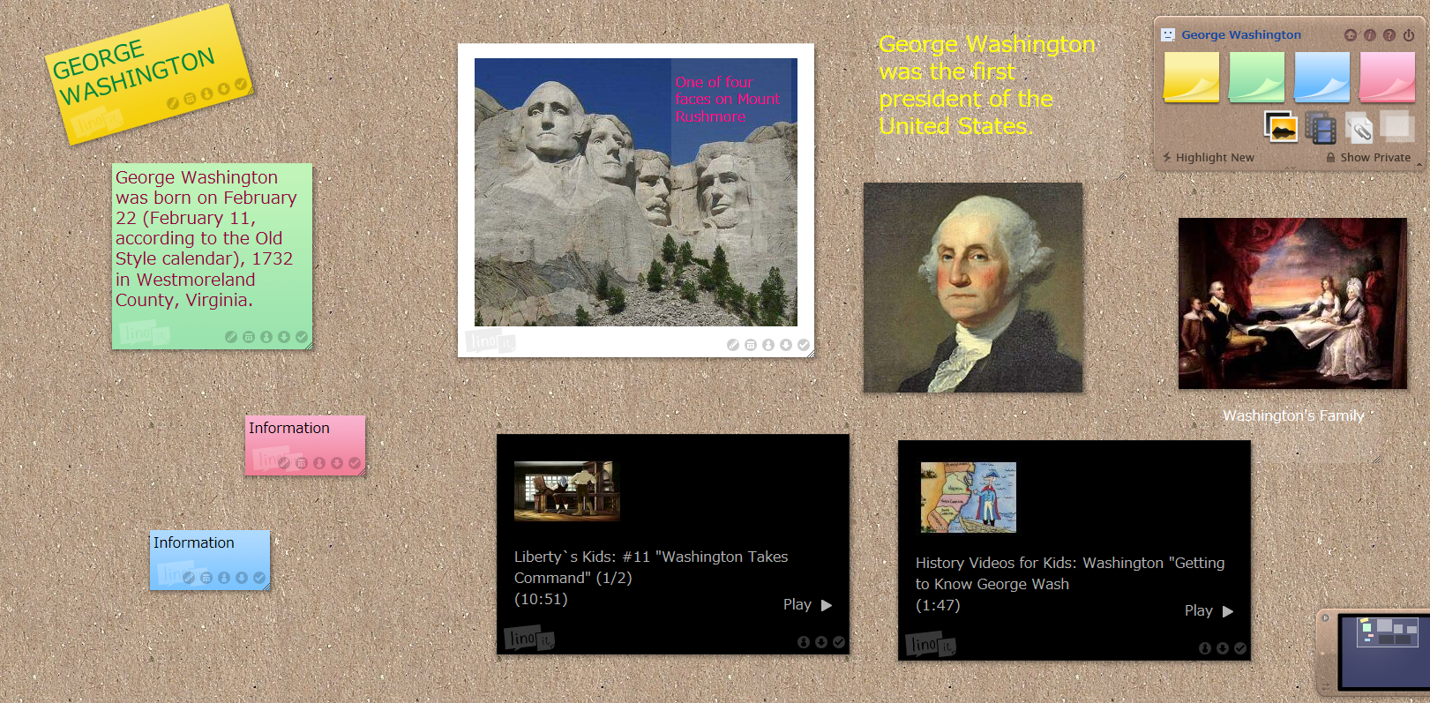
LINOIT.COM
ASSIGNMENT: 2 videos, 3 pictures, text labeling pictures, Sticky note for Title of Board, 3 more sticky notes with information about your topic.

