TEACHING ELEMENTARY SOCIAL STUDIES
Edu 315
SPRING, 2017
Instructor: Dr. Arlys E. Peterson
Classroom: Glidden 212
Meeting Time: MW 12:30 – 1:45 PM
Office Hours: 9:00 a.m.-11:00 a.m. M W
Email: arlys.peterson@usiouxfalls.edu
Class Web Sites: K-8 Social Studies Methods
http://faculty.usiouxfalls.edu/arpeterson/

=================================================================
Mission Statement-University of Sioux Falls
The University of Sioux Falls, a Christian University in the liberal arts tradition, educates students in the humanities, sciences, and professions. The traditional motto of the University if Culture for Service; that is, we seek to foster academic excellence and the development of mature Christian persons for service to God and humankind in the world.
Course Description:
This course will help prepare students to become effective social studies educators capable of teaching K-8 students the content knowledge, the intellectual skills, and the civic values necessary to fulfill the responsibilities of citizenship in a democracy. Special attention is given to National and State Social Studies Standards, effective teaching strategies, assessment, addressing the individual and cultural diversity of all learners, developing lessons based on state standards, integrating technology, and designing materials that are appropriate for K-8 social studies.
Prerequisite: Students are required to be admitted to the teacher education program before taking the class.
Textbook: K-8 Social Studies Methods website
Peterson Home Page: http://faculty.usiouxfalls.edu/arpeterson/
WIKI: http://k-8socialstudiesmethods2016.wikispaces.com/

References:
Web site for South Dakota Content Standards
National Council for the Social Studies
Instructional Methods: lecture, discussion groups, group work, videos, student presentations, computer work
Professional Education Requirements
This class was designed to show alignment with the USF School of Education’s “Teacher as Developing Professional” Curriculum Model, the ISTE Technology Teacher Standards, and the National Social Studies Standards.

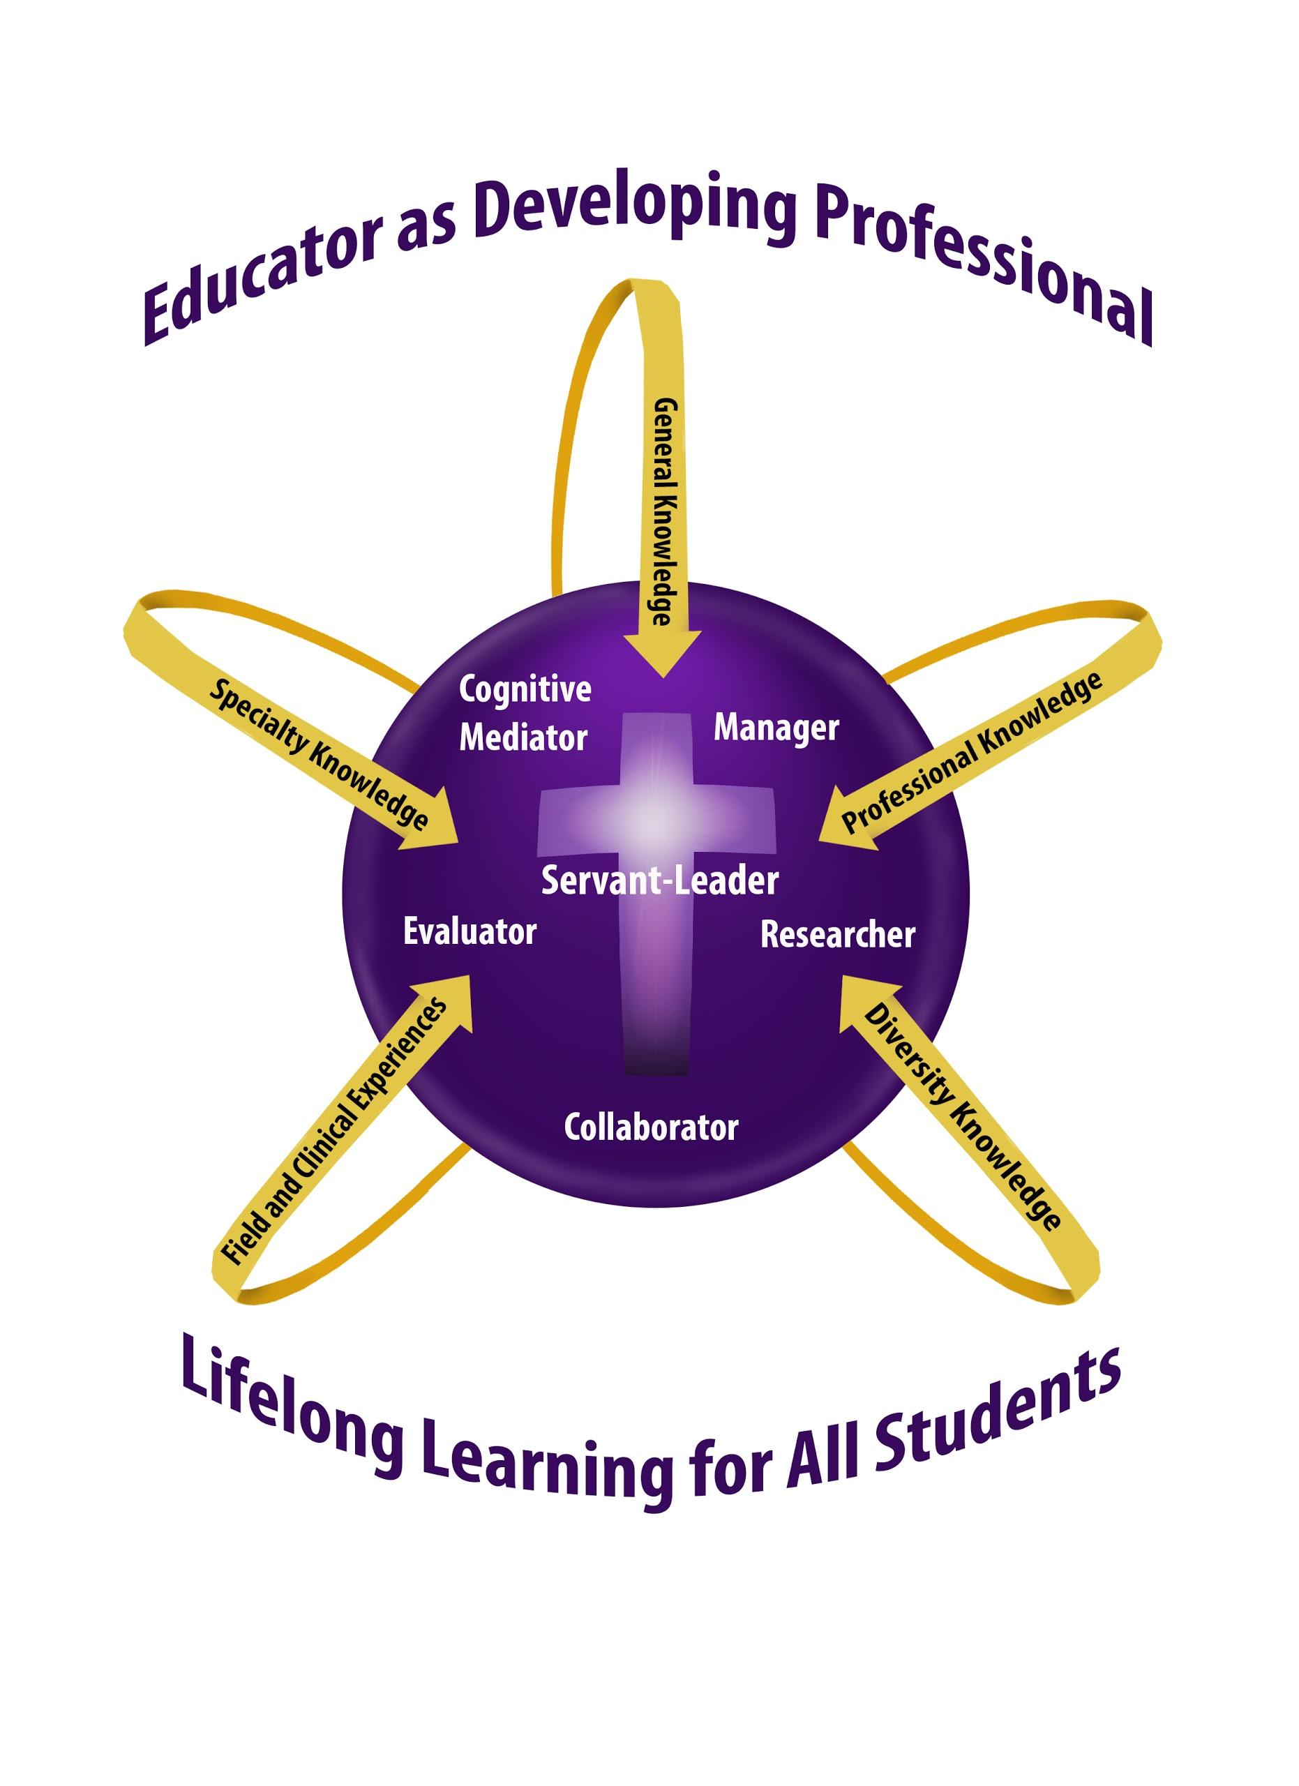
Knowledge Base
The knowledge base for candidates in all teacher education programs at University of Sioux Falls is based on the conceptual framework, “Teacher as Developing Professional.” Coursework may emphasize some or all of the components of the framework: cognitive mediator, manager, researcher, communicator, evaluator, and servant-leader.
As cognitive mediator, the teacher helps students to become independent learners who construct meaning by combining new information with their own background knowledge.
As researcher, the teacher seeks to improve educational practices within the school setting, using an inquiry approach to serve students more effectively.
As servant leader, the teacher is able to integrate research on the development of moral reasoning, values, and ethical sensitivity into the classroom while following the model of empathetic personal interaction provided by Jesus Christ.
As evaluator, the teacher maximizes students’ learning by using a full range of formal and informal information-gathering processes in order to respond appropriately to student individual differences.
As communicator, the teacher is skill in modes of communication that will enable effective communication and collaboration with other educators, parents, and families.
As manager, the teacher plans and organizes the learning environment, established and maintains a positive learning climate, and implements effective intervention strategies.
ISTE TECHNOLOGY STANDARDS FOR TEACHERS
1 .Facilitate and inspire student learning and creativity
2. Design and develop digital age learning experiences and assessments
3. Model digital age work and learning
4. Promote and model digital citizenship and responsibility
5. Engage in professional growth and leadership
**Descriptions for these Standards are found at:
http://www.iste.org/standards/standards/standards-for-teachers

NATIONAL SOCIAL STUDIES STANDARDS
1. Learning and Development
2. Differences in Learning Styles
3. Critical Thinking, Problem Solving, and Performance Skills
4. Active Learning and Motivation
5. Inquiry, Collaboration, and Supportive Classroom Interaction
6. Planning Instruction
7. Assessment
8. Reflection and Personal Growth
9. Professional Leadership

InTASC TEACHING STANDARDS
The InTASC Model Core Teaching Standards
Standard #1: Learner Development.
Standard #2: Learning Differences.
Standard #3: Learning Environments.
Standard #4: Content Knowledge
Standard #5: Application of Content.
Standard #6: Assessment.
Standard #7: Planning for Instruction.
Standard #8: Instructional Strategies.
Standard #9: Professional Learning and Ethical Practice.
Standard #10: Leadership and Collaboration.

SOCIAL STUDIES OBJECTIVES
- Curriculum model: Researcher, Communicator; ISTE: 2 & 5; InTASC 7
Students will research and demonstrate understanding of the National and State K-8 Social Studies Standards.
- Curriculum Model: Cognitive Mediator, Researcher; ISTE 1,2,3; InTASC 8
- SS Standards: 6. Planning Instruction: Social studies teachers should possess the knowledge, capabilities, and dispositions to plan instruction for the appropriate school levels based on understanding of subject matter, students, the community, and curriculum goals.
Students will research and demonstrate understanding of several different teaching strategies that produce effective learning environments in K-8 social studies classrooms.
- Curriculum Model: Cognitive Mediator; ISTE: 2, 3, 4, 5; InTASC 2 & 7
- 2. Differences in Learning Styles: Social studies teachers should possess the knowledge, capabilities, and dispositions to create at the appropriate school levels learning experiences that fit the different approaches to learning of diverse learners.
Students will design social studies lessons that are developmentally appropriate and sensitive to the needs, values, and interests of a diverse group of students.
- Curriculum Model: Cognitive Mediator, Researcher; ISTE 5; InTASC 2 & 8
- 2. Differences in Learning Styles: Social studies teachers should possess the knowledge, capabilities, and dispositions to create at the appropriate school levels learning experiences that fit the different approaches to learning of diverse learners.
Students will research and demonstrate ways to use the Multiple Intelligences in social studies lessons.
- Curriculum Model: Cognitive Mediator, Researcher, Evaluator; ISTE: 3,4,5; InTASC 7 & 8
- 5. Inquiry, Collaboration, and Supportive Classroom Interaction: Social studies teachers should possess the knowledge, capabilities, and dispositions to use at the appropriate school levels verbal, nonverbal, and media communication techniques that foster active inquiry, collaboration, and supportive interaction in the classroom.
Students will research and evaluate ways to use technology and online resources in lessons to support meaningful learning.
- Curriculum Model: Cognitive Mediator; InTASC 7
- 5. Inquiry, Collaboration, and Supportive Classroom Interaction: Social studies teachers should possess the knowledge, capabilities, and dispositions to use at the appropriate school levels verbal, nonverbal, and media communication techniques that foster active inquiry, collaboration, and supportive interaction in the classroom.
Student will use trade books to support meaningful learning in lessons.
- Curriculum Model: Cognitive Mediator, ;ISTE: 1,2; InTASC 8
- 8. Reflection and Personal Growth: Social studies teachers should possess the knowledge, capabilities, and dispositions to develop as reflective practitioners and continuous learners.
Students will complete an online Social Studies Wiki to post assignments.

Course Requirements:
1. Attendance and Participation in class discussions - after three class absences in social studies, you will be required to drop the class.
2. Twitter Reports
3. Lesson Plans
4. Lesson Presentation
5. Online Wiki Site
6. Test

Grading Scale:
96-99 = A 80-82 = C+
93-95 = A- 78-79 = C
90-92 =B+ 75-77 = C-
87-89 = B
83-86 = B-

Assignments:
All assignments are listed on the EDU 315 Class Web Page:
http://faculty.usiouxfalls.edu/ArPeterson/SoStMethodsSpring2017.htm

Honesty Statement:
USF holds firmly to the conviction that personal and intellectual integrity should be fundamentals at a Christian university. For this reason, USF expects all students and employees of the university to act honestly, ethically, and fairly and to avoid activities that would compromise the academic mission of the university. Academic misconduct, including plagiarism, will result in written notification to the student, his/her academic advisor, the department head of the offered course, and the Vice-President of Academic Affairs. Plagiarizing occurs when one does not cite work taken from books, journals, works of others, or electronic sources. Full information can be found at: https://www.usiouxfalls.edu/academic/student_handbook

Accommodations:
COMPLIANCE WITH THE AMERICANS WITH DISABILITIES ACT: The Americans with Disabilities Act (ADA) is a federal anti-discrimination statute that provides comprehensive civil rights for persons with disabilities. Among other things, this legislation requires that all students with disabilities be guaranteed a learning environment that provides for reasonable accommodation of their disabilities. If you believe you have a disability requiring an accommodation, please contact Learning Accessibility Services at (605) 331-6740 or access@usiouxfalls.edu. Accommodations can only be arranged through this office, which is located in the Academic Success Center (McDonald Center).

USF Academic Success Center
To assist students in enriching their intellectual lives and pursuing academic success, USF provides a variety of services through the Academic Success Center (ASC). The ASC coordinates with the USF Math Center, the USF Writing Center, and other campus programs to aid students seeking to master course content or to develop study skills (e.g., time management, note taking, test taking, reading strategies) necessary to become effective, life-long learners. The services of the USF Academic Success Center—located in the McDonald University Center—are free. For additional information, including the schedule of available services, please visit the ASC web page at http://www.usiouxfalls.edu/asc, or contact Dr. Greg Dyer (greg.dyer@usiouxfalls.edu), Director of the Academic Success Center.
USF Writing Center
An excellent avenue for receiving thoughtful feedback on your writing is the USF Writing Center, located in the lower level of Mears Library. The services of the USF Writing Center are free, and they are available to you either by appointment or on a drop-in basis. For additional information about the USF Writing Center, including the hours of operation and the services they offer, please check the website at www.usiouxfalls.edu/writing_center.

ALL ASSIGNMENTS ARE LISTED ON THE CLASS WEB PAGE AT:
http://faculty.usiouxfalls.edu/ArPeterson/SoStMethodsSpring2017.htm

