TECHNOLOGY IN EDUCATION
EDU 240 – 3 s.h.
SPRING, 2016
Instructor: Dr. Arlys E. Peterson
1:00 - 2:15 - Tuesdays and Thursdays
Glidden RM 115
Office: Education Department
e-mail: arlys.peterson@usiouxfalls.edu
Class Web Page: http://faculty.usiouxfalls.edu/arpeterson/TECHINEDSpring2016.htm
======================================================================
Vision Statement-University of Sioux Falls
The University of Sioux Falls, a Christian University in the liberal arts tradition, educates students in the humanities, sciences, and professions. The traditional motto of the University if Culture for Service; that is, we seek to foster academic excellence and the development of mature Christian persons for service to God and humankind in the world.

Course Description:
Designed as an introductory computer applications course for teachers, this class provides experience in technology programs for K-12 classrooms. The course includes hands-on experience with telecommunications, multimedia, hypermedia, and K-12 software programs. Candidates also prepare a website for portfolio preparation. (3 s.h.)

Textbook:
Online Resources

Instructional Methods:
Lecture, Discussions, Hands-on Projects
Class Web Page: http://faculty.usiouxfalls.edu/arpeterson/TECHINEDSpring2016.htm
Wiki: http://techinedusf.wikispaces.com/

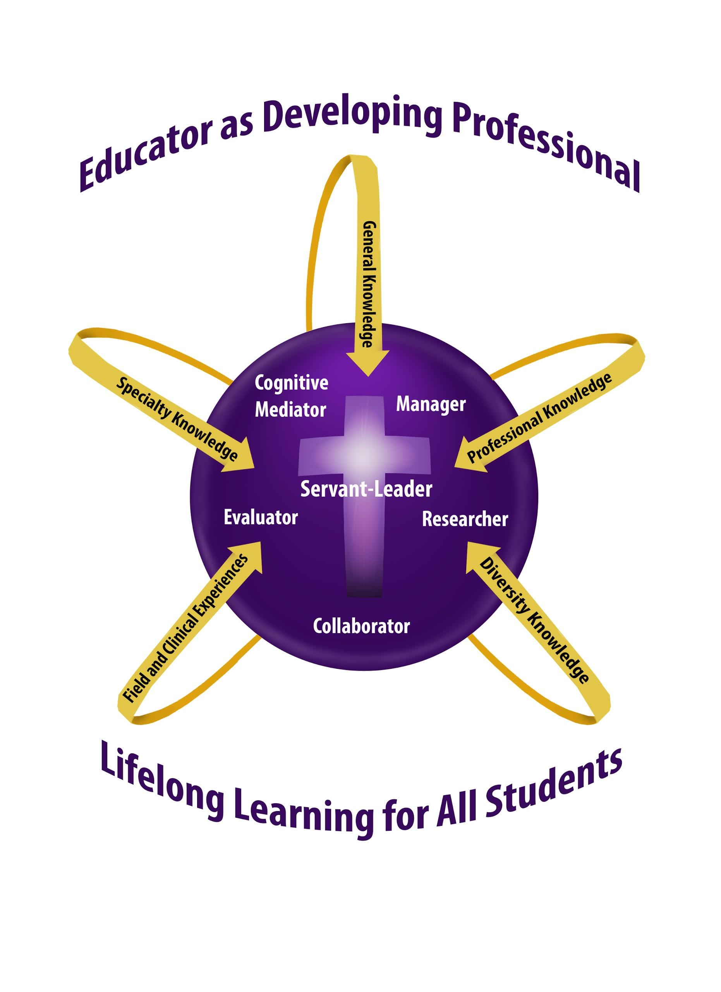
Knowledge Base
The knowledge base for candidates in all teacher education programs at University of Sioux Falls is based on the conceptual framework, “Teacher as Developing Professional.” Coursework may emphasize some or all of the components of the framework: cognitive mediator, manager, researcher, communicator, evaluator, and servant-leader.

As cognitive mediator, the teacher helps students to become independent learners who construct meaning by combining new information with their own background knowledge.

As researcher, the teacher seeks to improve educational practices within the school setting, using an inquiry approach to serve students more effectively.
As servant leader, the teacher is able to integrate research on the development of moral reasoning, values, and ethical sensitivity into the classroom while following the model of empathetic personal interaction provided by Jesus Christ.
As evaluator, the teacher maximizes students’ learning by using a full range of formal and informal information-gathering processes in order to respond appropriately to student individual differences.
As collaborator, the teacher is skill in modes of communication that will enable effective communication and collaboration with other educators, parents, and families.
As manager, the teacher plans and organizes the learning environment, established and maintains a positive learning climate, and implements effective intervention strategies.

Professional Education Requirements
This class was designed to show alignment with the USF School of Education’s “Teacher as Developing Professional” Curriculum Model, the South Dakota Professional Education Requirements -SDPER24:16:08:36 - and ISTE Standards.

ISTE Standards:
1. Facilitate and Inspire Student Learning and Creativity: Teachers use their knowledge of subject matter, teaching and learning, and technology to facilitate experiences that advance student learning, creativity, and innovation in both face-to-face and virtual environments.
a. Promote, support, and model creative and innovative thinking and inventiveness
b. Engage students in exploring real-world issues and solving authentic problems using digital tools and resources
c. Promote student reflection using collaborative tools to reveal and clarify students’ conceptual understanding and thinking, planning, and creative processes
d. Model collaborative knowledge construction by engaging in learning with students, colleagues, and others in face-to-face and virtual environments
2. Design and Develop Digital Age Learning Experiences and Assessments: Teachers design, develop, and evaluate authentic learning experiences and assessment incorporating contemporary tools and resources to maximize content learning in context and to develop the knowledge, skills, and attitudes identified in the NETS·S.
a. Design or adapt relevant learning experiences that incorporate digital tools and resources to promote student learning and creativity
b. Develop technology-enriched learning environments that enable all students to pursue their individual curiosities and become active participants in setting their own educational goals, managing their own learning, and assessing their own progress
c. Customize and personalize learning activities to address students’ diverse learning styles, working strategies, and abilities using digital tools and resources
d. Provide students with multiple and varied formative and summative assessments aligned with content and technology standards and use resulting data to inform learning and teaching.

3. Model Digital Age Work and Learning: Teachers exhibit knowledge, skills, and work processes representative of an innovative professional in a global and digital society.
a. Demonstrate fluency in technology systems and the transfer of current knowledge to new technologies and situations
b. Collaborate with students, peers, parents, and community members using digital tools and resources to support student success and innovation
c. Communicate relevant information and ideas effectively to students, parents, and peers using a variety of digital age media and formats d. Model and facilitate effective use of current and emerging digital tools to locate, analyze, evaluate, and use information resources to support research and learning
Effective teachers model and apply the NETS·S as they design, implement, and assess learning experiences to engage students and improve learning; enrich professional practice; and provide positive models for students, colleagues, and the community. All teachers should meet the following standards and performance indicators.
iste.org/nets
4. Promote and Model Digital Citizenship and Responsibility: Teachers understand local and global societal issues and responsibilities in an evolving digital culture and exhibit legal and ethical behavior in their professional practices.
a. Advocate, model, and teach safe, legal, and ethical use of digital information and technology, including respect for copyright, intellectual property, and the appropriate documentation of sources
b. Address the diverse needs of all learners by using learner-centered strategies providing equitable access to appropriate digital tools and resources
c. Promote and model digital etiquette and responsible social interactions related to the use of technology and information
d. Develop and model cultural understanding and global awareness by engaging with colleagues and students of other cultures using digital age communication and collaboration tools
5. Engage in Professional Growth and Leadership: Teachers continuously improve their professional practice, model lifelong learning, and exhibit leadership in their school and professional community by promoting and demonstrating the effective use of digital tools and resources.
a. Participate in local and global learning communities to explore creative applications of technology to improve student learning
b. Exhibit leadership by demonstrating a vision of technology infusion, participating in shared decision making and community building, and developing the leadership and technology skills of others
c. Evaluate and reflect on current research and professional practice on a regular basis to make effective use of existing and emerging digital tools and resources in support of student learning
d. Contribute to the effectiveness, vitality, and self- renewal of the teaching profession and of their school and community
NETS·T © 2008 International Society for Technology in Education. ISTE® is a registered trademark of the International Society for Technology in Education.

InTASC TEACHING STANDARDS
The InTASC Model Core Teaching Standards
Standard #1: Learner Development.
Standard #2: Learning Differences.
Standard #3: Learning Environments.
Standard #4: Content Knowledge
Standard #5: Application of Content.
Standard #6: Assessment.
Standard #7: Planning for Instruction.
Standard #8: Instructional Strategies.
Standard #9: Professional Learning and Ethical Practice.
Standard #10: Leadership and Collaboration.

CLASS OBJECTIVES

- Students will demonstrate competencies in using technology by creating technology projects that follow the South Dakota State Curriculum Standards and SD Technology Standards and National ISTE Standards in their area of teaching. (Cognitive Mediator, Researcher, Evaluator, Collaborator; ISTE 1-5; InTASC 7 & 8)
- Students will demonstrate competencies in using technology hardware and software that are being used in educational environments. (iPads, Web 2.0 Tools, Chromebooks, SmartBoards, Wikis, Twitter, and online multimedia programs). (Cognitive Mediator, Researcher, Evaluator, Collaborator; ISTE 1-5; InTASC 7 & 8)
- Students will gain information on setting up a Personal Learning Network through the use of online tools. (Twitter, Blogs, Chat Rooms, Facebook) (Cognitive Mediator, Researcher, Collaborator; ISTE 5; InTACS 9 & 10)
- Students will research and learn how technology is enhancing the 21st Century Skills of Students. (Researcher, Evaluator, Collaborator; ISTE 5; InTASC 9)
- Students will learn how to use online Webinars to gain professional development in their major area of study. (Researcher, Evaluator, Collaborator; ISTE 5; InTASC 9)
- Students will research how technology is being used in K-12 education environments and how technology used around the world is affecting K-12 education. (Cognitive Mediator, Researcher, Evaluator, Collaborator; ISTE 1-4; InTASC 9)
- Students will research Internet Safety and Bullying in K-12 School Environments. (Researcher, Evaluator, Collaborator; ISTE 3-4; InTASC 9)
- Students will demonstrate competencies in developing an online technology lesson plan in their area of study. (Cognitive Mediator, Researcher, Evaluator, Collaborator; ISTE 1-2; InTASC 7 & 8)

Attendance Policy: Attending class is very important! After three absences, you will be asked to drop the class. Being late more than five minutes to class will count as an absence.

Assignments: All assignments are due one week after they are assigned, unless otherwise told. If they are 1-5 days late, only half of the points will be given. After 5 days, no points will be given.

Course Requirements:

1. Completion of assignments as assigned in class
2. Completion of SD Standards technology/ISTE projects
3. Completion of educational technology research reports
4. Completion of a technology presentation
5. Completion of a Wiki page with all assignments posted on it
6. Posting assignments on the LMS
7. Attendance and participation in class discussions

Grading Scale:
96-99 = A
93-95 = A-
90-92 =B+
87-89 = B
83-86 = B-
80-82 = C+
78-79 = C
75-77 = C-
Accommodations:

COMPLIANCE WITH THE AMERICANS WITH DISABILITIES ACT: The Americans with Disabilities Act (ADA) is a federal anti-discrimination statute that provides comprehensive civil rights for persons with disabilities. Among other things, this legislation requires that all students with disabilities be guaranteed a learning environment that provides for reasonable accommodation of their disabilities. If you believe you have a disability requiring an accommodation, please contact Learning Accessibility Services at (605) 331-6740 or access@usiouxfalls.edu. Accommodations can only be arranged through this office, which is located in the Academic Success Center (McDonald Center).

Honesty Statement:
USF holds firmly to the conviction that personal and intellectual integrity should be fundamentals at a Christian university. For this reason, USF expects all students and employees of the university to act honestly, ethically, and fairly and to avoid activities that would compromise the academic mission of the university. Academic misconduct, including plagiarism, will result in written notification to the student, his/her academic advisor, the department head of the offered course, and the Vice-President of Academic Affairs. Plagiarizing occurs when one does not cite work taken from books, journals, works of others, or electronic sources. Full information can be found at: https://www.usiouxfalls.edu/academic/student_handbook
USF Academic Success Center
To assist students in enriching their intellectual lives and pursuing academic success, USF provides a variety of services through the Academic Success Center (ASC). The ASC coordinates with the USF Math Center, the USF Writing Center, and other campus programs to aid students seeking to master course content or to develop study skills (e.g., time management, note taking, test taking, reading strategies) necessary to become effective, life-long learners. The services of the USF Academic Success Center—located in the McDonald University Center—are free. For additional information, including the schedule of available services, please visit the ASC web page at http://www.usiouxfalls.edu/asc, or contact Dr. Greg Dyer (greg.dyer@usiouxfalls.edu), Director of the Academic Success Center.

USF Writing Center
An excellent avenue for receiving thoughtful feedback on your writing is the USF Writing Center, located in the lower level of Mears Library. The services of the USF Writing Center are free, and they are available to you either by appointment or on a drop-in basis. For additional information about the USF Writing Center, including the hours of operation and the services they offer, please check the website at www.usiouxfalls.edu/writing_center.

CLASS SCHEDULE ON THE INTERNET
CLASS ASSIGNMENTS LISTED ON THE LMS

