Print onto Sticky Notes
Getting Started:
- Open a Google Presentation or PowerPoint.
- In the Page Setup area, change the size of the slides to 7.5 x 7.5.
- Add any desired design/content to the slide.
(You can add any combination of text, clip art, pictures, tables, etc.)
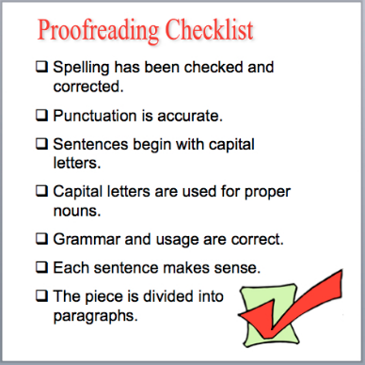
- Duplicate the slide so that you have a total of 4 identical slides.
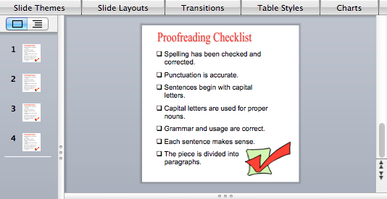

Printing Instructions:
