TEACHING ELEMENTARY SOCIAL STUDIES
Edu 315

Spring, 2014
Instructor: Dr. Arlys E. Peterson
Classroom: Glidden 212
Meeting Time: MWF 12:30 - 2:30 PM
Office Hours: 9:00 a.m.-11:00 a.m. M W
Email: arlys.peterson@usiouxfalls.edu
Class Web Sites: K-8 Social Studies Methods
http://faculty.usiouxfalls.edu/arpeterson/

==============================================================================
Mission Statement-University of Sioux Falls
The University of Sioux Falls, a Christian University in the liberal arts tradition, educates students in the humanities, sciences, and professions. The traditional motto of the University if Culture for Service; that is, we seek to foster academic excellence and the development of mature Christian persons for service to God and humankind in the world.
Course Description:
This course will help prepare students to become effective social studies educators capable of teaching K-8 students the content knowledge, the intellectual skills, and the civic values necessary to fulfill the responsibilities of citizenship in a democracy. Special attention is given to National and State Social Studies Standards, effective teaching strategies, assessment, addressing the individual and cultural diversity of all learners, developing lessons based on state standards, integrating technology, and designing materials that are appropriate for K-8 social studies.
Prerequisite: Students are required to be admitted to the teacher education program before taking the class.
Textbook: K-8 Social Studies Methods website
Peterson Home Page: http://faculty.usiouxfalls.edu/arpeterson/
Portaportal: http://my.portaportal.com/ - http://guest.portaportal.com/arlyspterson
WIKI: http://usfmethods.wikispaces.com/

References:
Web site for South Dakota Content Standards
National Council for the Social Studies
Instructional Methods: lecture, discussion groups, group work, videos, student presentations, computer work
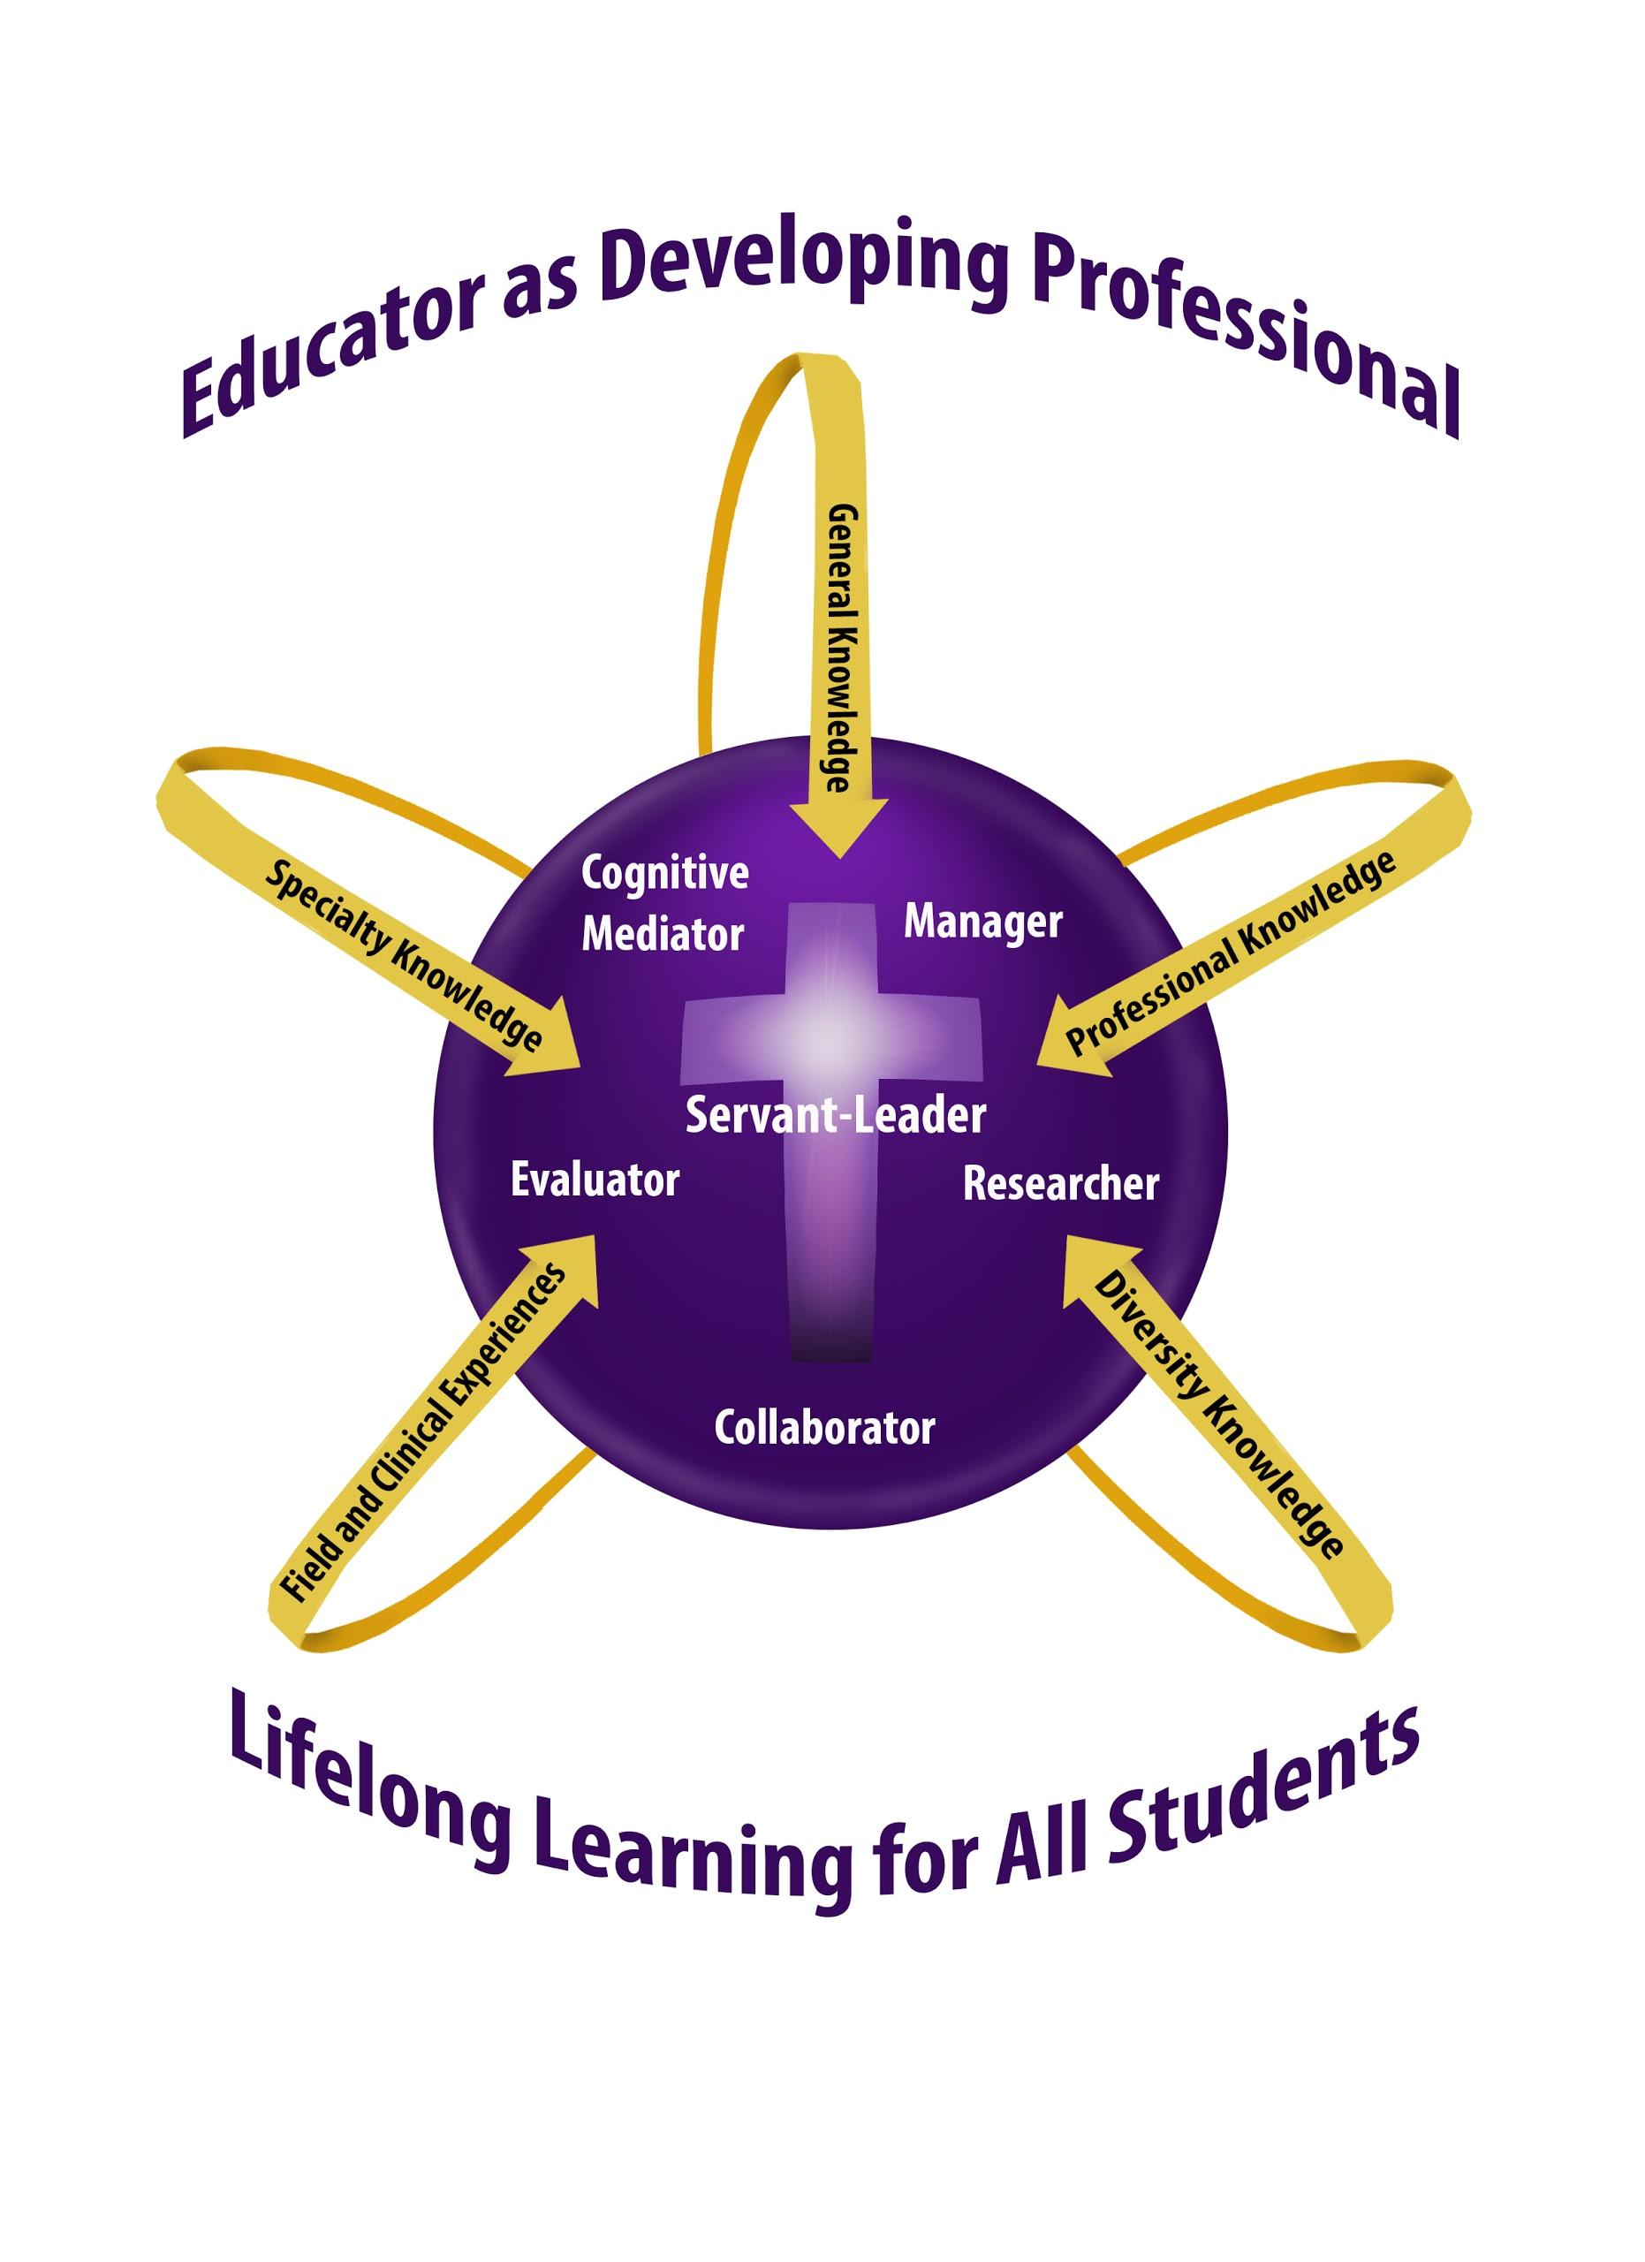
Knowledge Base
The knowledge base for candidates in all teacher education programs at University of Sioux Falls is based on the conceptual framework, “Teacher as Developing Professional.” Coursework may emphasize some or all of the components of the framework: cognitive mediator, manager, researcher, communicator, evaluator, and servant-leader.
As cognitive mediator, the teacher helps students to become independent learners who construct meaning by combining new information with their own background knowledge.
As researcher, the teacher seeks to improve educational practices within the school setting, using an inquiry approach to serve students more effectively.
As servant leader, the teacher is able to integrate research on the development of moral reasoning, values, and ethical sensitivity into the classroom while following the model of empathetic personal interaction provided by Jesus Christ.
As evaluator, the teacher maximizes students’ learning by using a full range of formal and informal information-gathering processes in order to respond appropriately to student individual differences.
As communicator, the teacher is skill in modes of communication that will enable effective communication and collaboration with other educators, parents, and families.
As manager, the teacher plans and organizes the learning environment, established and maintains a positive learning climate, and implements effective intervention strategies.

National Social Studies Standards
1. LEARNING AND DEVELOPMENT Social studies teachers should possess the knowledge, capabilities, and dispositions to provide learning opportunities at the appropriate school levels that support learners’ intellectual, social, and personal development.
2. DIFFERENCES IN LEARNING STYLES Social studies teachers should possess the knowledge, capabilities, and dispositions to create at the appropriate school levels learning experiences that fit the different approaches to learning of diverse learners.
3. CRITICAL THINKING, PROBLEM SOLVING, AND PERFORMANCE SKILLS Social studies teachers should possess the knowledge, capabilities, and dispositions to use at the appropriate school levels a variety of instructional strategies to encourage student development of critical thinking, problem solving, and performance skills.
4. ACTIVE LEARNING AND MOTIVATION Social studies teachers should possess the knowledge, capabilities, and dispositions to create at the appropriate school levels learning environments that encourage social interaction, active engagement in learning, and self-motivation.
5. INQUIRY, COLLABORATION, AND SUPPORTIVE CLASSROOM INTERACTION Social studies teachers should possess the knowledge, capabilities, and dispositions to use at the appropriate school levels verbal, nonverbal, and media communication techniques that foster active inquiry, collaboration, and supportive interaction in the classroom.
6. PLANNING INSTRUCTION Social studies teachers should possess the knowledge, capabilities, and dispositions to plan instruction for the appropriate school levels based on understanding of subject matter, students, the community, and curriculum goals.
7. ASSESSMENT Social studies teachers should possess the knowledge, capabilities, and dispositions to use formal and informal assessment strategies at the appropriate school levels to evaluate and ensure the Pedagogical Standards 5 National Standards for Social Studies Teachers continuous intellectual, social, and physical development of learners. They should be able to assess student learning using various assessment formats, including performance assessment, fixed response, open-ended questioning, and portfolio strategies.
8. REFLECTION AND PROFESSIONAL GROWTH Social studies teachers should possess the knowledge, capabilities, and dispositions to develop as reflective practitioners and continuous learners.
9. PROFESSIONAL LEADERSHIP Social studies teachers should possess the knowledge, capabilities, and dispositions to foster cross- subject matter collaboration and other positive relationships with school colleagues, and positive associations with parents and others in the larger community to support student learning and well-being.

SOCIAL STUDIES OBJECTIVES
- Curriculum model: Researcher; Communicator.
Students will research and demonstrate understanding of the National and State K-8 Social Studies Standards.
- Curriculum Model: Cognitive Mediator; Researcher
- SS Standards: 6. Planning Instruction: Social studies teachers should possess the knowledge, capabilities, and dispositions to plan instruction for the appropriate school levels based on understanding of subject matter, students, the community, and curriculum goals.
Students will research and demonstrate understanding of several different teaching strategies that produce effective learning environments in K-8 social studies classrooms.
- Curriculum Model: Cognitive Mediator
- 2. Differences in Learning Styles: Social studies teachers should possess the knowledge, capabilities, and dispositions to create at the appropriate school levels learning experiences that fit the different approaches to learning of diverse learners.
Students will design social studies lessons that are developmentally appropriate and sensitive to the needs, values, and interests of a diverse group of students.
- Curriculum Model: Cognitive Mediator; Researcher
- 2. Differences in Learning Styles: Social studies teachers should possess the knowledge, capabilities, and dispositions to create at the appropriate school levels learning experiences that fit the different approaches to learning of diverse learners.
Students will research and demonstrate ways to use the Multiple Intelligences in social studies lessons.
- Curriculum Model: Cognitive Mediator; Researcher; Evaluator
- 5. Inquiry, Collaboration, and Supportive Classroom Interaction: Social studies teachers should possess the knowledge, capabilities, and dispositions to use at the appropriate school levels verbal, nonverbal, and media communication techniques that foster active inquiry, collaboration, and supportive interaction in the classroom.
Students will research and evaluate ways to use technology and online resources in lessons to support meaningful learning.
- Curriculum Model: Cognitive Mediator
- 5. Inquiry, Collaboration, and Supportive Classroom Interaction: Social studies teachers should possess the knowledge, capabilities, and dispositions to use at the appropriate school levels verbal, nonverbal, and media communication techniques that foster active inquiry, collaboration, and supportive interaction in the classroom.
Student will use trade books to support meaningful learning in lessons.

- Curriculum Model: Cognitive Mediator; Manager
- 8. Reflection and Personal Growth: Social studies teachers should possess the knowledge, capabilities, and dispositions to develop as reflective practitioners and continuous learners.
Students will complete an online Social Studies Wiki and Edmodo to post assignments.

Course Requirements:
1. Attendance and Participation in class discussions - after two class absences in social studies, you will be required to drop the class.
2. Journal reports
3. Lesson Plans
4. Lesson Presentation
5. Online Wiki and Edmodo Site
6. Test

Grading Scale:
96-99 = A
93-95 = A-
90-92 =B+
87-89 = B
83-86 = B-
80-82 = C+
78-79 = C
75-77 = C-

Assignments:
All assignments are listed on the EDU 315 Class Web Page:
http://faculty.usiouxfalls.edu/arpeterson/SoStMethodsSpring2014.htm

Honesty Statement:
USF holds firmly to the conviction that personal and intellectual integrity should be fundamentals at a Christian university. For this reason, USF expects all students and employees of the university to act honestly, ethically, and fairly and to avoid activities that would compromise the academic mission of the university. Academic misconduct, including plagiarism, will result in written notification to the student, his/her academic advisor, the department head of the offered course, and the Vice-President of Academic Affairs. Plagiarizing occurs when one does not cite work taken from books, journals, works of others, or electronic sources. Full information can be found at: https://www.usiouxfalls.edu/academic/student_handbook

Accommodations:
If you anticipate barriers related to the format or requirements of this course, please meet with me so that we can discuss ways to ensure your full participation. If you determine that disability related accommodations are necessary, please register with Learning Accessibility Services and notify me of your eligibility. Learning Accessibility Services is located in the McDonald Center and may be reached at 605-331-6740 or access@usiouxfalls.edu. Accommodations can only be arranged through this office.
USF Academic Success Center
To assist students in enriching their intellectual lives and pursuing academic success, USF provides a variety of services through the Academic Success Center (ASC). The ASC coordinates with the USF Math Center, the USF Writing Center, and other campus programs to aid students seeking to master course content or to develop study skills (e.g., time management, note taking, test taking, reading strategies) necessary to become effective, life-long learners. The services of the USF Academic Success Center—located in the McDonald University Center—are free. For additional information, including the schedule of available services, please visit the ASC web page at http://www.usiouxfalls.edu/asc, or contact Dr. Greg Dyer (greg.dyer@usiouxfalls.edu), Director of the Academic Success Center.
USF Writing Center
An excellent avenue for receiving thoughtful feedback on your writing is the USF Writing Center, located in the lower level of Mears Library. The services of the USF Writing Center are free, and they are available to you either by appointment or on a drop-in basis. For additional information about the USF Writing Center, including the hours of operation and the services they offer, please check the website at www.usiouxfalls.edu/writing_center.

