WORD | DEFINITION | PICTURE
island | a piece of land  surrounded by water | 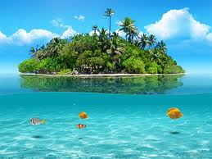
canal
gulf
coast
continent
ocean
peninsula
river

