SOUTH DAKOTA TECHNOLOGY STANDARDS  (COPY THE STANDARD FOR YOUR GRADE LEVEL)  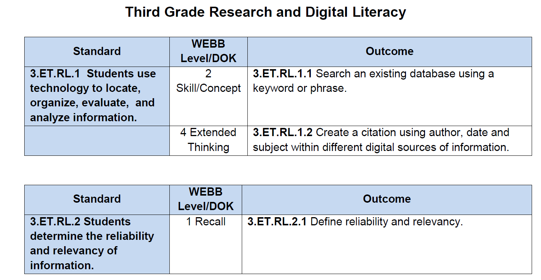  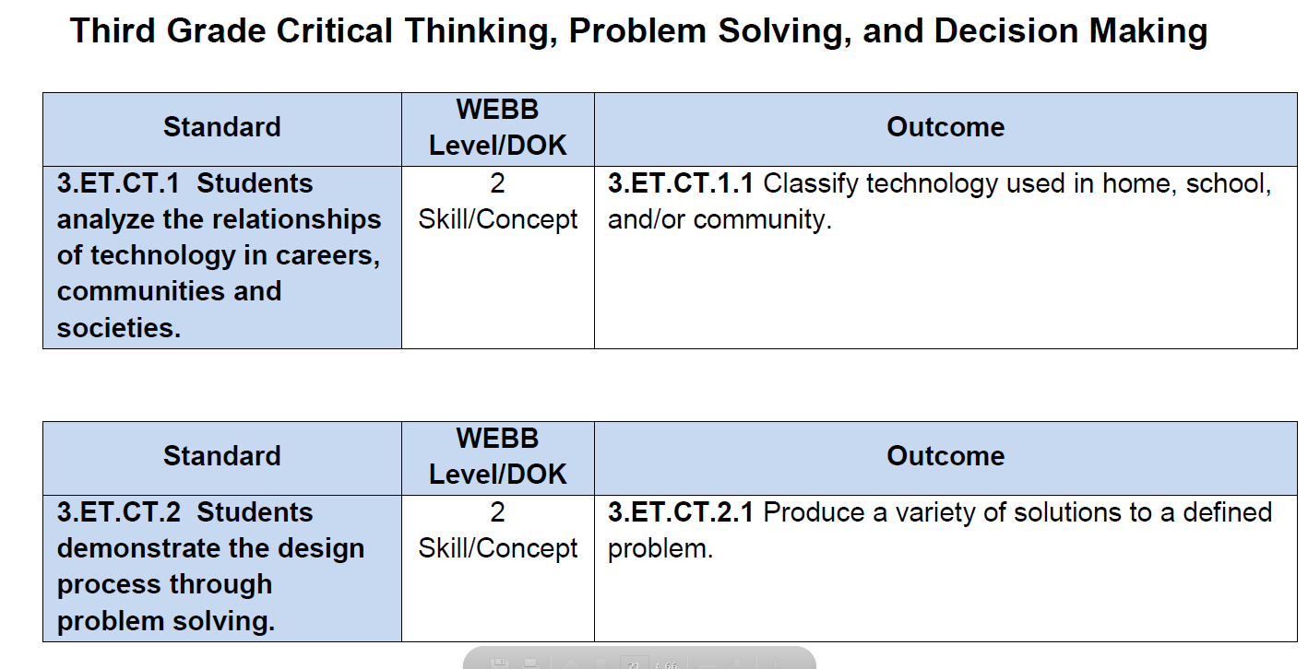  Ex.  Copy each of the 6 strands  Strand 1: Research and Digital Literacy  Strand 2: Critical Thinking, Problem-Solving and Decision-Making  Strand 3: Digital Citizenship  Strand 4: Technology Operations and Concepts  Strand 5: Creativity and Innovation  Strand 6: Communication and Collaboration | HOW ARE YOU MEETING THAT STANDARD?

