Landforms  Complete the 4  Quizlet activities.  Flashcards  Learn  Speller  Quiz | Landforms  Click Explore to view landforms.  Complete the worksheet. | What Are Landforms?  Watch the video. Name 2 types of landforms discussed in the video. | 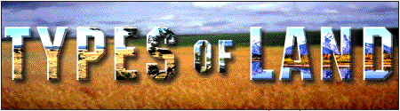  Click on the names on the map. What are the names of the 3 deserts? What are the names of the 2 mountain ranges?
Landform Regions of  the United States  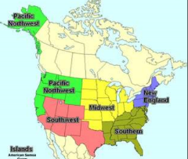  Click on Show All. Answer the  3 questions below the map. | World Book  Type in the name of the landform assigned to you in the Search box. Write down 3 things you learned about the landform. | Landform Game  Complete the Landforms Memory Game. | Different Landforms  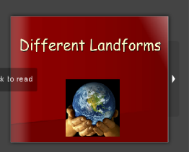  Read the Flip book  about landforms.

